# CMPE355 – Data Communication & Computer Network I: Fall 2023

**Date submitted:** 27/11/2023.

### Lab Instructor Name: Eng. Heba Dawoud

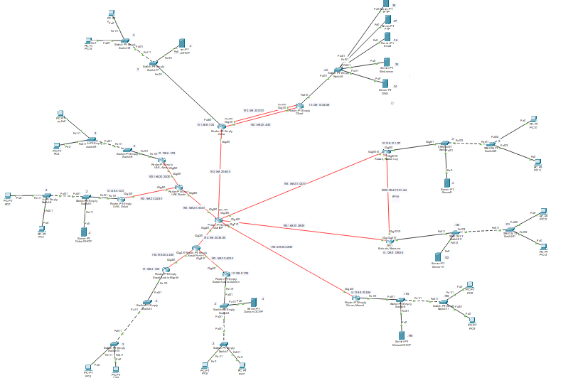**Main Topology:**

**Subnetting Using VLSM**

|  |  |  |  |  |  |  |  |
| --- | --- | --- | --- | --- | --- | --- | --- |
| Name | Network Address | Subnet Mask | Required Hosts | Available Hosts | Unused Hosts | Usable Range | Broadcast |
| Dubai | 10.128.0.0/22 | 255.255.252.0 | 795 | 1022 | 227 | 10.128.0.1 - 10.128.3.254 | 10.128.3.255 |
| Riyadh | 10.128.4.0/23 | 255.255.254.0 | 500 | 510 | 10 | 10.128.4.1 - 10.128.5.254 | 10.128.5.255 |
| Ajman | 10.128.6.0/23 | 255.255.254.0 | 340 | 510 | 170 | 10.128.6.1 - 10.128.7.254 | 10.128.7.255 |
| Doha | 10.128.8.0/24 | 255.255.255.0 | 224 | 254 | 30 | 10.128.8.1 - 10.128.8.254 | 10.128.8.255 |
| Damam | 10.128.9.0/25 | 255.255.255.128 | 120 | 126 | 6 | 10.128.9.1 - 10.128.9.126 | 10.128.9.127 |
| Manama | 10.128.9.128/26 | 255.255.255.192 | 52 | 62 | 10 | 10.128.9.129 - 10.128.9.190 | 10.128.9.191 |
| Muscat | 10.128.9.192/26 | 255.255.255.192 | 38 | 62 | 24 | 10.128.9.193 - 10.128.9.254 | 10.128.9.255 |
| Kuwait City | 10.128.10.0/27 | 255.255.255.224 | 25 | 30 | 5 | 10.128.10.1 - 10.128.10.30 | 10.128.10.31 |
| Cloud | 10.128.10.32/28 | 255.255.255.240 | 8 | 14 | 6 | 10.128.10.33 - 10.128.10.46 | 10.128.10.47 |

**LAN (10.142.0.0/12)**

**IPv6 (2005:0FB4:F21C::/64)**

|  |  |  |  |  |
| --- | --- | --- | --- | --- |
| Name | Network Address | Hosts Needed | Unused Hosts | Usable Range |
| Bahrain | 2005:FB4:F21C::/64 | 6 | (2^64)-7 | 2005:FB4:F21C::1/64 - |
|  |  |  |  | 2005:FB4:F21C::FFFF:FFFF:FFFF:FFFF/64 |
| Kuwait City | 2005:FB4:F21D:1::/64 | 6 | (2^64)-7 | 2005:FB4:F21D:1::1/64 |
|  |  |  |  | 2005:FB4:F21D:1:FFFF:FFFF:FFFF:FFFF/64 |

|  |  |  |  |  |  |  |  |
| --- | --- | --- | --- | --- | --- | --- | --- |
| Name | Network Address | Mask | Hosts Needed | Hosts Available | Unused Hosts | Usable Range | Broadcast |
| WAN 1 | 190.168.20.0/30 | 255.255.255.252 | 2 | 2 | 0 | 190.168.20.1 - 190.168.20.2 | 190.168.20.3 |
| WAN 2 | 190.168.20.4/30 | 255.255.255.252 | 2 | 2 | 0 | 190.168.20.5 - 190.168.20.6 | 190.168.20.7 |
| WAN 3 | 190.168.20.8/30 | 255.255.255.252 | 2 | 2 | 0 | 190.168.20.9 - 190.168.20.10 | 190.168.20.11 |
| WAN 4 | 190.168.20.12/30 | 255.255.255.252 | 2 | 2 | 0 | 190.168.20.13 - 190.168.20.14 | 190.168.20.15 |
| WAN 5 | 190.168.20.16/30 | 255.255.255.252 | 2 | 2 | 0 | 190.168.20.17 - 190.168.20.18 | 190.168.20.19 |
| WAN 6 | 190.168.20.20/30 | 255.255.255.252 | 2 | 2 | 0 | 190.168.20.21 - 190.168.20.22 | 190.168.20.23 |
| WAN 7 | 190.168.20.24/30 | 255.255.255.252 | 2 | 2 | 0 | 190.168.20.25 - 190.168.20.26 | 190.168.20.27 |
| WAN 8 | 190.168.20.28/30 | 255.255.255.252 | 2 | 2 | 0 | 190.168.20.29 - 190.168.20.30 | 190.168.20.31 |
| WAN 9 | 190.168.20.32/30 | 255.255.255.252 | 2 | 2 | 0 | 190.168.20.33 - 190.168.20.34 | 190.168.20.35 |
| WAN 10 | 190.168.20.36/30 | 255.255.255.252 | 2 | 2 | 0 | 190.168.20.37 - 190.168.20.38 | 190.168.20.39 |
| WAN 11 | 190.168.20.40/30 | 255.255.255.252 | 2 | 2 | 0 | 190.168.20.41 - 190.168.20.42 | 190.168.20.43 |
| WAN 12 | 190.168.20.44/30 | 255.255.255.252 | 2 | 2 | 0 | 190.168.20.45 - 190.168.20.46 | 190.168.20.47 |

**WAN (190.168.20.0/25)**

**Dubai**

**Topology:**

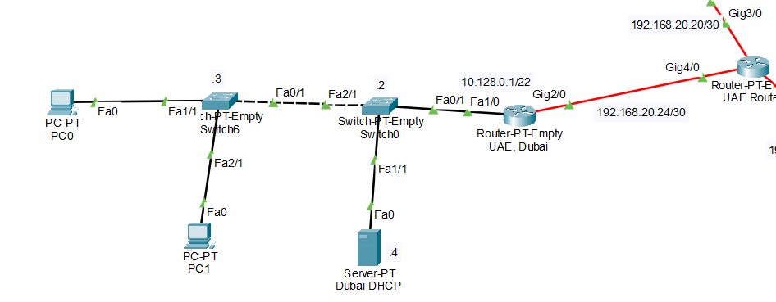

**Network Address: 10.128.0.0/22**

**Subnet Mask: 255.255.252.0**

**First Usable:10.128.0.1/22**

**Last Usable:10.128.3.254**

**Broadcast: 10.128.3.255**

**Tests: Dubai to Ajman**

**Riyadh**

**Topology:**

**Network Address: 10.128.4.0/23**

**Subnet Mask: 255.255.254.0**

**First Usable: 10.128.4.1**

**Last Usable: 10.128.5.254**

**Broadcast: 10.128.5.255**

**Tests: Riyadh to Dubai**

**Ajman**

**Topology:**

**Network Address: 10.128.6.0/23**

**Subnet Mask: 255.255.254.0**

**First Usable: 10.128.6.1**

**Last Usable: 10.128.7.254**

**Broadcast:10.128.7.255**

**Tests: Ajman to Doha**

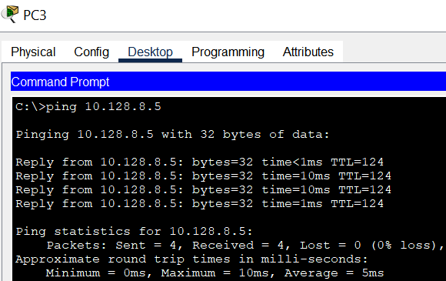

**Doha**

**Topology:**

**Network Address: 10.128.8.0/24**

**Subnet Mask: 255.255.255.0**

**First Usable: 10.128.8.1**

**Last Usable: 10.128.8.254**

**Broadcast: 10.128.8.255**

**Tests: Doha to Cloud**

**Damam**

**Topology:**

**Network Address: 10.128.9.0/25**

**Subnet Mask: 255.255.255.128**

**First Usable: 10.128.9.1**

**Last Usable:10.128.9.126**

**Broadcast: 10.128.9.127**

**Tests: Damam to Riyadh**

**Manama**

**Topology:**

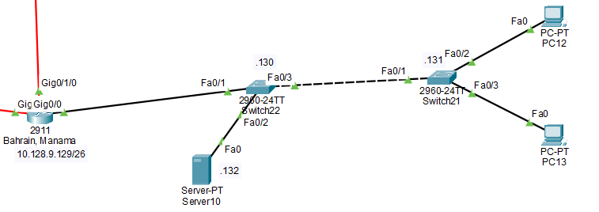

**Network Address: 10.128.9.128/26**

**Subnet Mask: 255.255.255.192**

**First Usable:10.128.9.129**

**Last Usable: 10.128.9.190**

**Broadcast: 10.128.9.191**

**Tests: Manama to Muscat**

**Muscat**

**Topology:**

**Network Address: 10.128.9.192/26**

**Subnet Mask: 255.255.255.192**

**First Usable:10.128.9.193**

**Last Usable: 10.128.9.254**

**Broadcast: 10.128.9.255**

**Tests: Muscat to Damam**

**Kuwait City**

**Topology:**

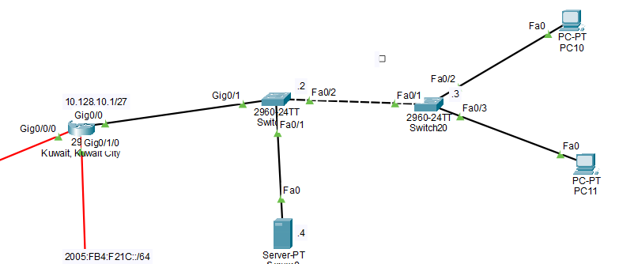

**Network Address: 10.128.10.0/27**

**Subnet Mask: 255.255.255.224**

**First Usable: 10.128.10.1**

**Last Usable: 10.128.10.30**

**Broadcast: 10.128.10.31**

**Tests: Kuwait City to Manama**

**Cloud**

**Topology:**

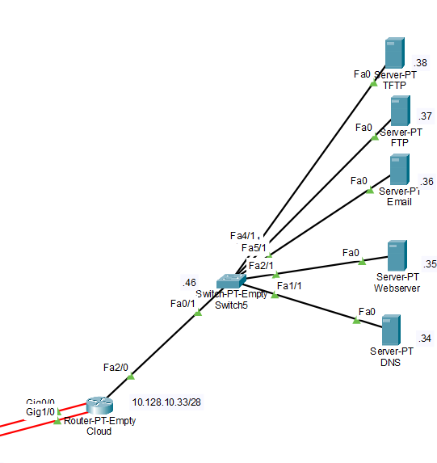

**Network Address: 10.128.10.32/28**

**Subnet Mask: 255.255.255.240**

**First Usable: 10.128.10.32**

**Last Usable: 10.128.10.46**

**Broadcast: 10.128.10.47**

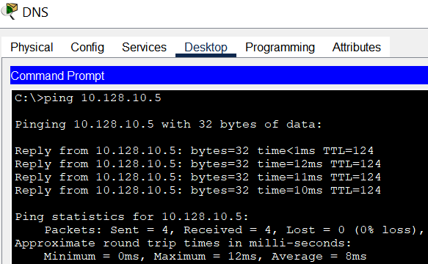**Tests: Cloud to Kuwait City**

**Cloud Servers**

1. **DNS**

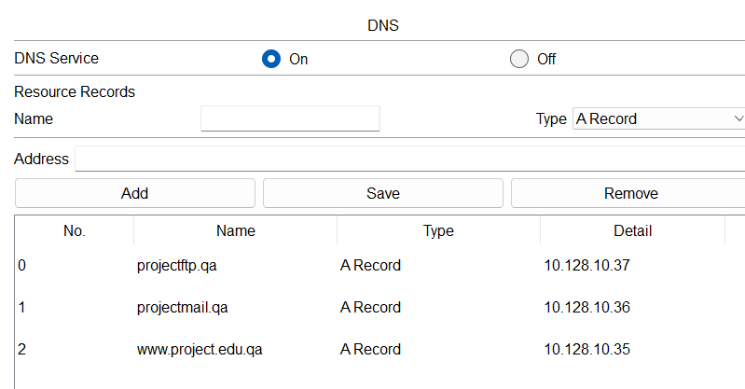

1. **Webserver and Webpage**

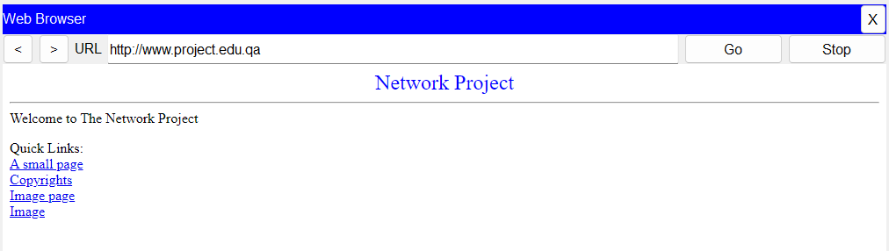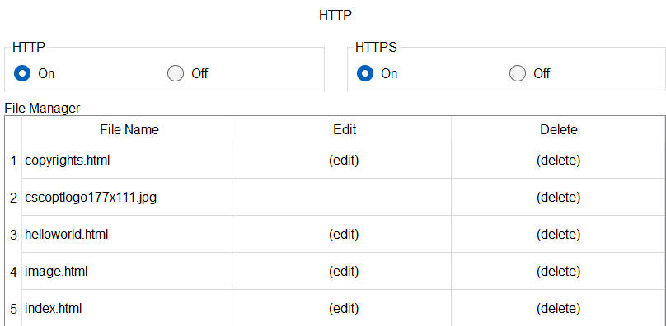

1. **Email**

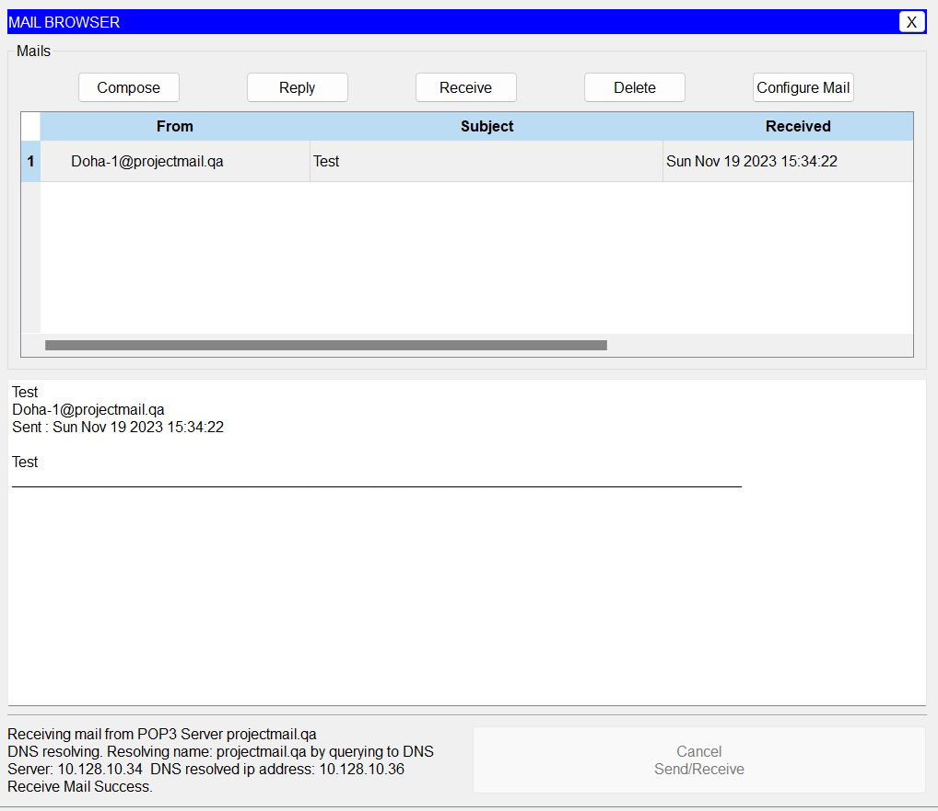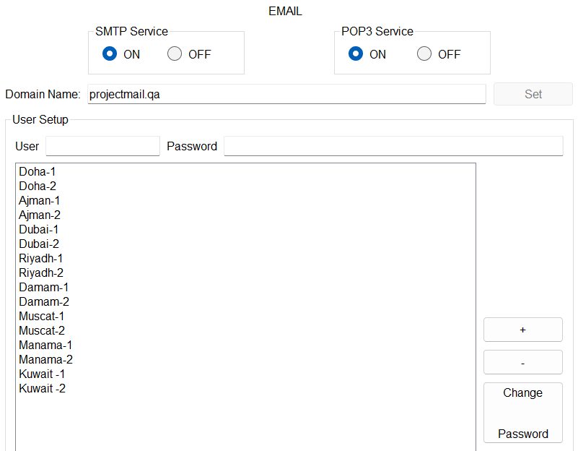

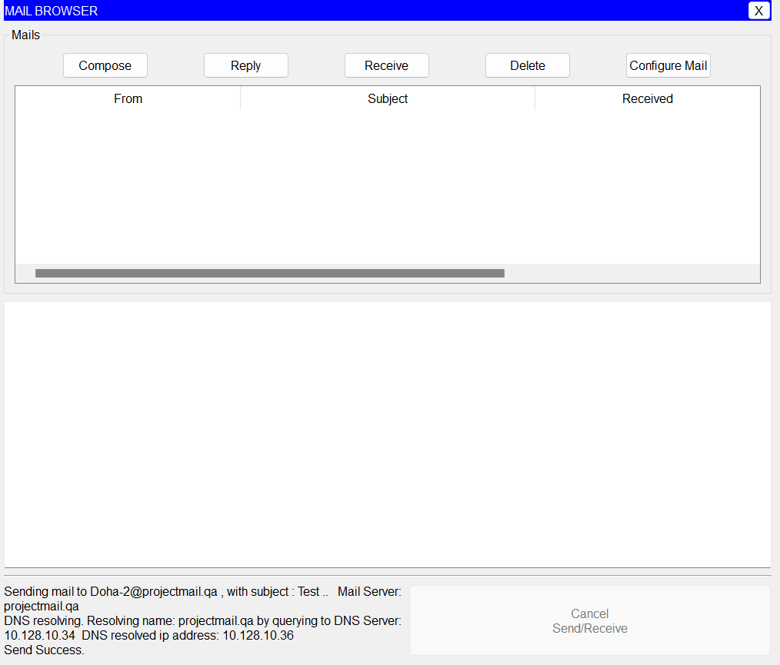

1. **FTP**

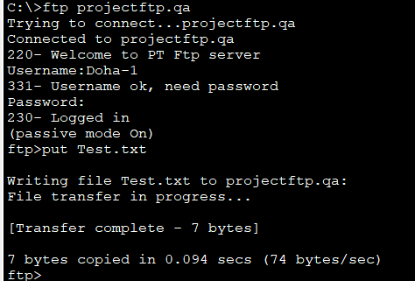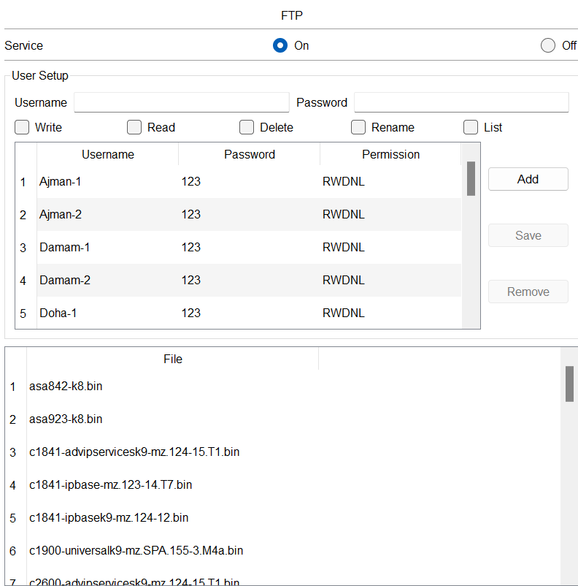

1. **TFTP**

